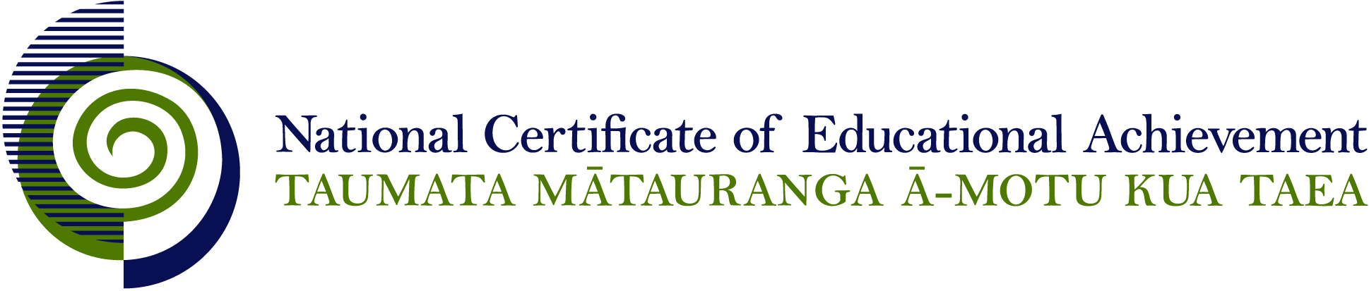

NCEA Level 2 History

Conditions of Assessment

General Information

Subject Reference | History
Domain | History
Level | 2

Conditions of Assessment

These Conditions provide guidelines for assessment against internally assessed Achievement Standards. Guidance is provided on:
- specific requirements for all assessments against this Standard
- appropriate ways of, and conditions for, gathering evidence
- ensuring that evidence is authentic.

Assessors must be familiar with guidance on assessment practice in learning centres, including enforcing timeframes and deadlines. The NZQA website offers resources that would be useful to read in conjunction with these Conditions of Assessment.

The learning centre’s Assessment Policy and Conditions of Assessment must be consistent with NZQA’s Assessment Rules for Schools with Consent to Assess. This link includes guidance for managing internal moderation and the collection of evidence.

Gathering Evidence

Internal assessment provides considerable flexibility in the collection of evidence. Evidence can be collected in different ways to suit a range of teaching and learning styles, and a range of contexts of teaching and learning. Care needs to be taken to allow students opportunities to present their best evidence against the Standard(s) that are free from unnecessary constraints.

It is recommended that the design of assessment reflects and reinforces the ways students have been learning. Collection of evidence for the internally assessed Standards could include, but is not restricted to, an extended task, an investigation, digital evidence (such as recorded interviews, blogs, photographs, or film), or a portfolio of evidence.

Effective assessment should suit the nature of the learning being assessed, provide opportunities to meet the diverse needs of all students, and be valid and fair.

Ensuring Authenticity of Evidence

Authenticity of student evidence needs to be assured regardless of the method of collecting evidence. This must be in line with the learning centre’s policy and NZQA’s Assessment Rules for Schools with Consent to Assess.

Ensure that the student’s evidence is individually identifiable and represents the student’s own work. The evidence must be an accurate reflection of what the student independently knows and can do, according to the Standard being assessed. This includes evidence submitted as part of a group assessment, evidence produced outside of class time or without assessor supervision, and evidence produced with any use of generative artificial intelligence tools (GenAI). GenAI use should be carefully considered in the context of the Standard being assessed and its Conditions of Assessment, discussed with students before the assessment, and its use must be acknowledged. For example, an investigation carried out over several sessions could include:
- teacher guidance on the nature and extent of acceptable GenAI use, if any
- assessor observations and conversations
- meeting with the student at set milestones or checkpoints
- the student’s record of progress, such as photographic entries or any GenAI prompts used.

Specific Information for Individual Internal Achievement Standards

Achievement Standard Number | 91229 History 2.1
Title | Carry out an inquiry of an historical event or place that is of significance to New Zealanders
Number of Credits | 4
Version | 2

The inquiry can focus on an event in a personal, local, national or international context.

The teacher may assist in the inquiry by:
  - aiding in the refinement of focusing questions
  - assisting in locating sources
  - conferring with individual students during the inquiry process.

Evidence for this achievement standard would be expected to be gathered from in and out of class activities to be completed by students over a period of time specified by the teacher. Where a group approach is used the teacher needs to ensure that there is evidence that each student has met all aspects of the standard.

This evidence may be generated from discussion, group work, research, decision making and/or reflection and will be presented in any media that clearly communicates the student’s understanding of the inquiry.

Students need to have access to their research materials in order to complete their evaluation of the inquiry process.

Achievement Standard Number | 91230 History 2.2
Title | Examine an historical event or place that is of significance to New Zealanders
Number of Credits | 5
Version | 2

An event can be examined in a personal, local, national or international context.

Evidence for this achievement standard would be expected to be gathered from in and out of class activities to be completed by students over a period of time specified by the teacher. Where a group approach is used the teacher needs to ensure that there is evidence that each student has met all aspects of the standard.

This evidence may be generated from discussion, group work, research, decision making and/or reflection and will be presented in any media that clearly communicates the student’s understanding of the historical event or place.

For example, possible formats for presentation of evidence could include:
- written – article, newspaper, letter, diary, journal, blog
- oral – recording , radio programme
- visual – timeline, poster, video, DVD, webpage, slide show, podcast or other digital formats
- or a portfolio format that includes a variety of media (for example, written notes, annotations, blog entries, video, graphics, photographs, podcasts, interactive mindmaps and other online presentations).

Although the evidence gathered as part of the inquiry for AS91229 can also be submitted for assessment against AS91230, this is not a requirement.

Achievement Standard Number | 91232 History 2.4
Title | Interpret different perspectives of people in an historical event that is of significance to New Zealanders
Number of Credits | 5
Version | 2

Students must use accurate historical information as the basis for the evidence communicated.

Evidence for this achievement standard would be expected to be gathered from in and out of class activities to be completed by students over a period of time specified by the teacher. Where a group approach is used the teacher needs to ensure that there is evidence that each student has met all aspects of the standard.

This evidence may be generated from discussion, group work, research, decision making and/or reflection and will be presented in any media that clearly communicates the student’s understanding of the historical event or place.

For example, possible formats for assessment could include:
- writing speeches
- answering interview questions
- writing diary entries
- constructing pamphlets
- role plays
- plays
- interviews
- essay

The format in which the evidence is submitted is not assessed.

Teachers can choose methods of assessment that do not require students to give a performance. This standard assesses students’ historical understanding of different perspectives, not the quality of a performance.

Students must use accurate historical information as the basis for the evidence communicated.

